Proposed Solution
Project Design Phase
Date | 15 February 2025
Team ID | SWTID-2026-1074
Project Name | SB Stocks
Team Size | 5
Team Leader | Venkatesh Illa
Team Members | Durga Meghana Kondempudi, Chandrika Narla, Mogali Shyam, Sravani Jagu
Maximum Marks | 2 Marks

Proposed Solution Template
S.No. | Parameter | Description
1 | Problem Statement (Problem to be solved) | Beginners and students want to practice stock trading and understand portfolio management without risking real money, since existing demo platforms are either paid, require KYC, or lack a clean end-to-end Buy/Sell/Portfolio/Wallet workflow.
2 | Idea / Solution Description | SB Stocks is a MERN stack paper-trading web application that gives every registered user a virtual wallet, a simulated live market of 15 NASDAQ-style stocks, and full order execution (Buy/Sell) with instant portfolio and wallet updates, transaction history, and an admin panel for platform oversight.
3 | Novelty / Uniqueness | Unlike static demo tools, SB Stocks runs a genuine background price-simulation engine (updating every 4 seconds) so prices fluctuate realistically, computes true average buy price on repeated purchases, and separates Intraday vs Delivery order types — all secured with JWT authentication and bcrypt password hashing.
4 | Social Impact / Customer Satisfaction | Gives risk-free, hands-on trading practice to students and first-time investors, building trading discipline and financial literacy before they commit real capital in live markets.
5 | Business Model (Revenue Model) | Currently a free educational tool; can be extended with a freemium model (premium analytics, advanced charting) or licensed to colleges/bootcamps as a classroom trading-simulation tool.
6 | Scalability of the Solution | Stateless JWT authentication and a MongoDB Atlas cluster allow horizontal scaling of the Node/Express API; the React frontend is deployed as a static build on Vercel and the API on Railway, so both tiers can scale independently as user load grows.
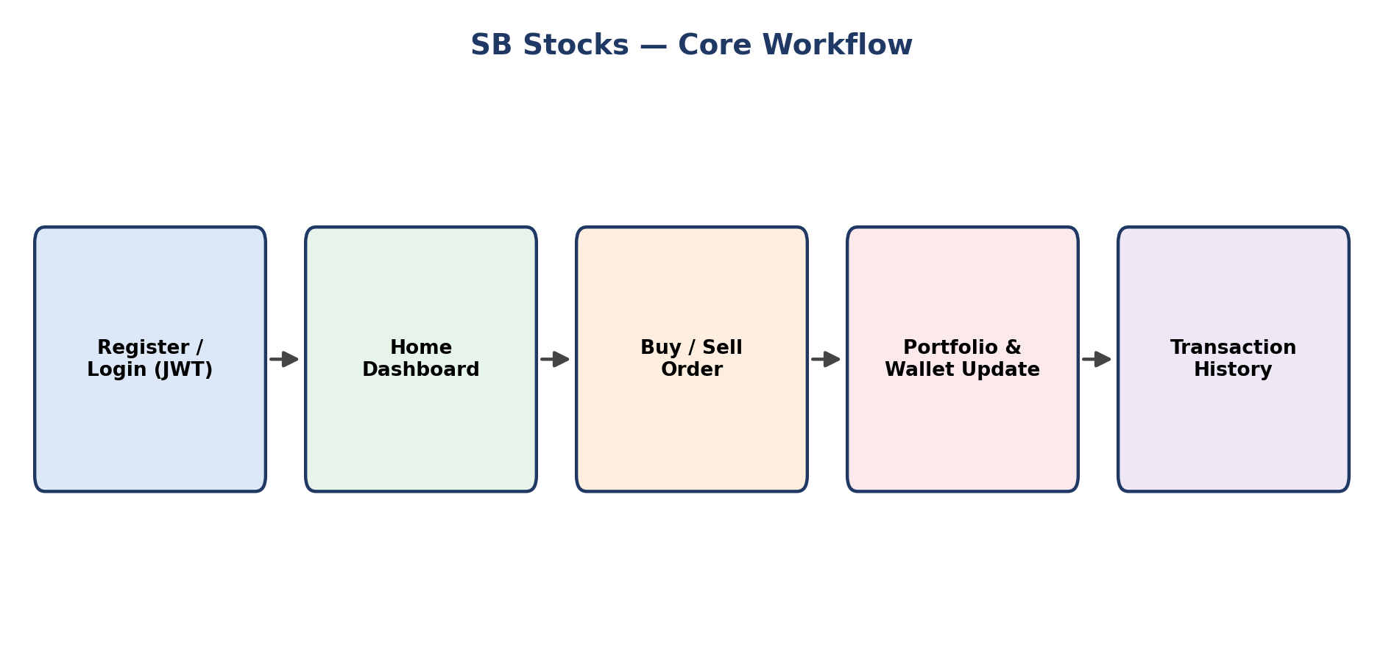
Figure: SB Stocks end-to-end user workflow

